Churn Prediction

|  |  |
| --- | --- |
| **Summary** | Ran the Churn Prediction Dataset using Jupyter Notebook |
| **URL** | <https://github.com/ikatsov/tensor-house/blob/master/promotions/churn-prediction-lstm.ipynb>  <https://github.com/ikatsov/tensor-house-data/tree/master/promotions/churn-media-data>  <https://scholar.harvard.edu/hadi/chData> |
| **Tools** | Jupyter Notebook |

Output Screenshots

3 Lesson Learned

# **Churn Prediction Output Screenshot**

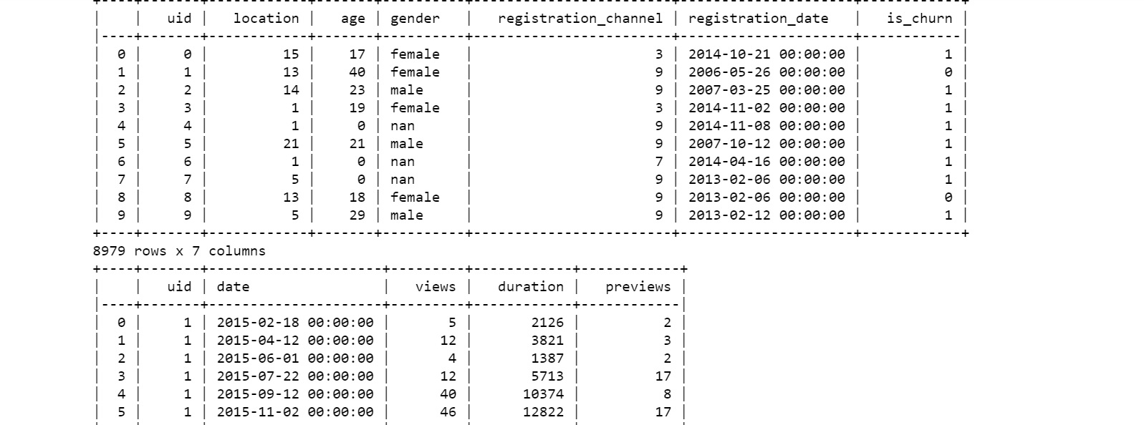

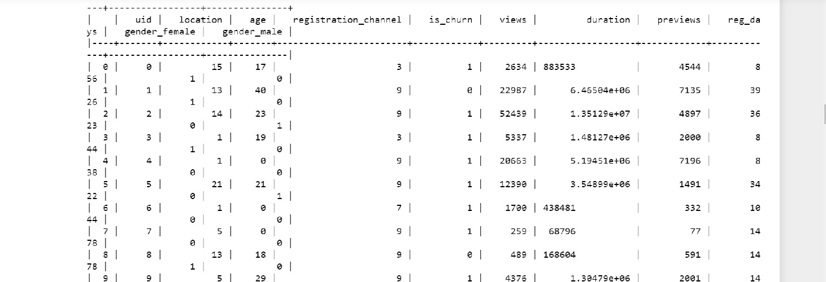

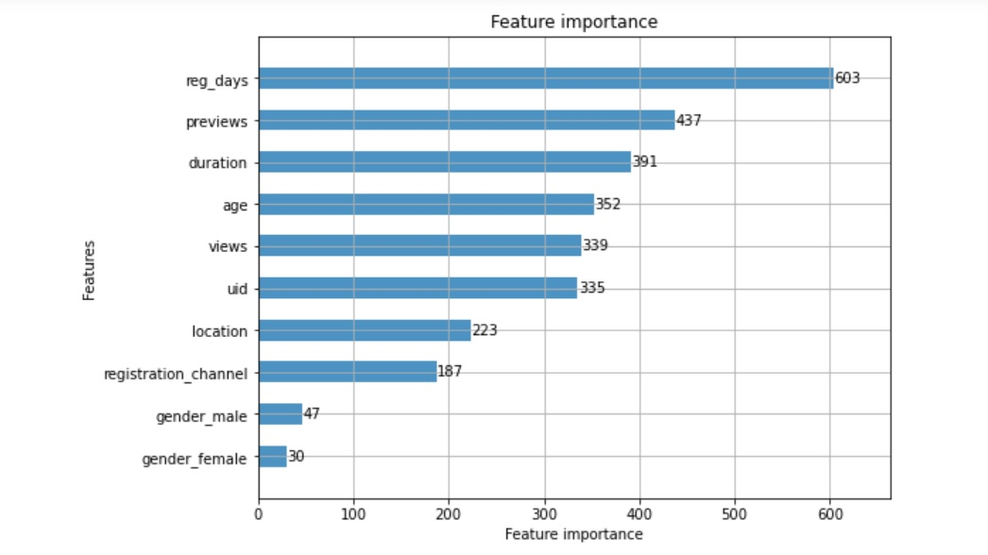

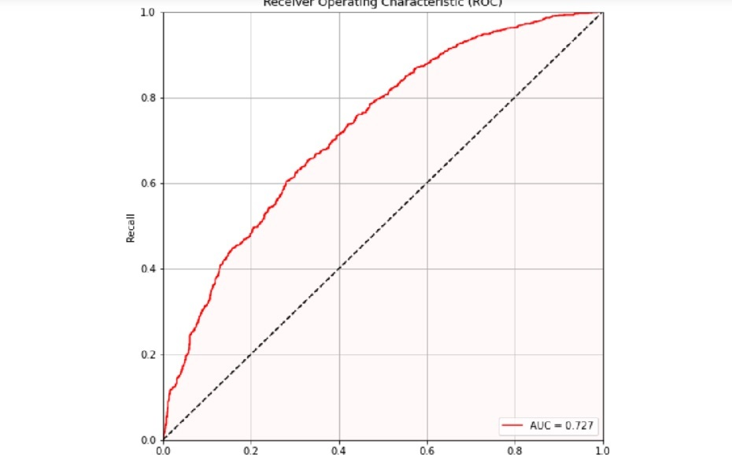

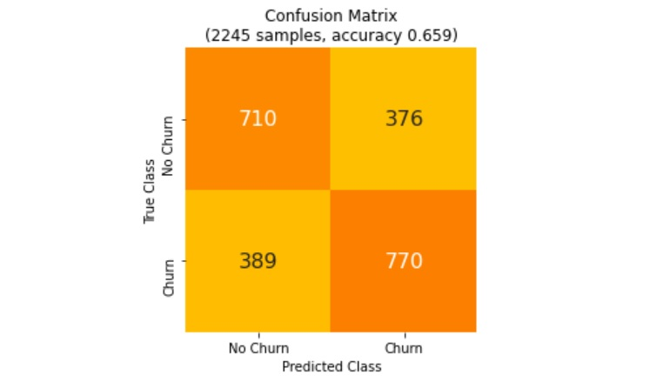

# **3 Lesson Learned**

1. LSTM easily outperforms the look-alike baseline. It is possible to improve the LightGBM baseline using more sophisticated feature engineering and tuning, but at the cost of extra effort.
2. Feature engineering is somewhat simpler because we use event-level attributes, not profile-level aggregates.
3. It's interesting to learn about features and their importance in prediction of target variable using Churn dataset